# Create an account on SAP Cloud Platform

Navigate to the following URL (or if it has changed yet again, Google SAP Cloud Platform):

<https://cloudplatform.sap.com/index.html>

Click **Start your free trial**.

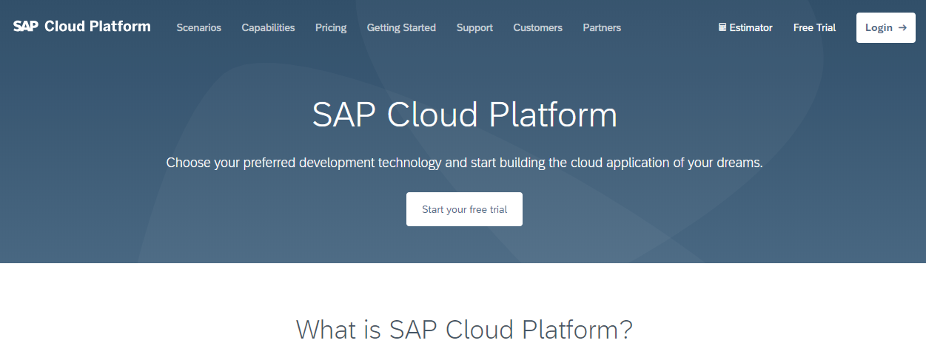

Then click **Start Trial**.

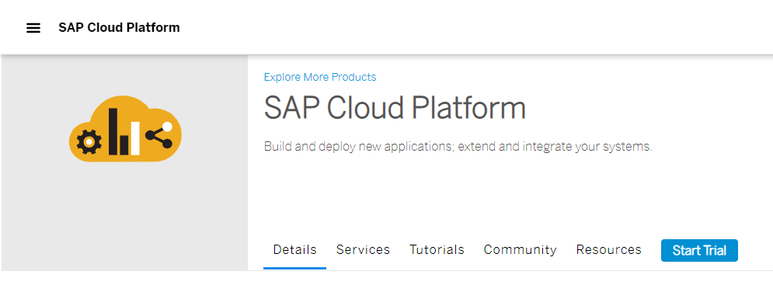

Click **Register** and complete the form to register.

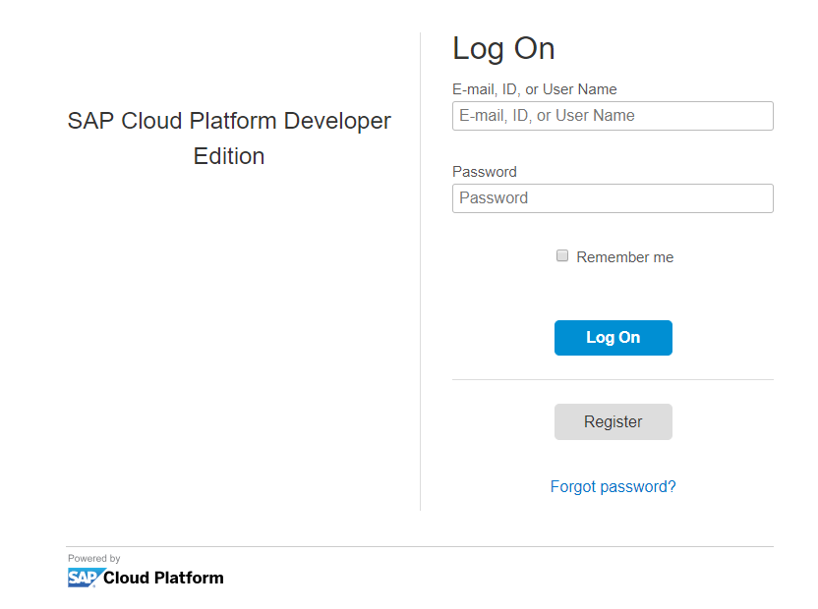

Once you log on you have a choice of using the Neo Trial (the standard SAP Cloud Platform environment) or the Cloud Foundry Trial. The Neo Trial is available to you indefinitely, but the Cloud Foundry Trial must be recreated every 90 days. Mendix requires the Cloud Foundry environment so click that tile.

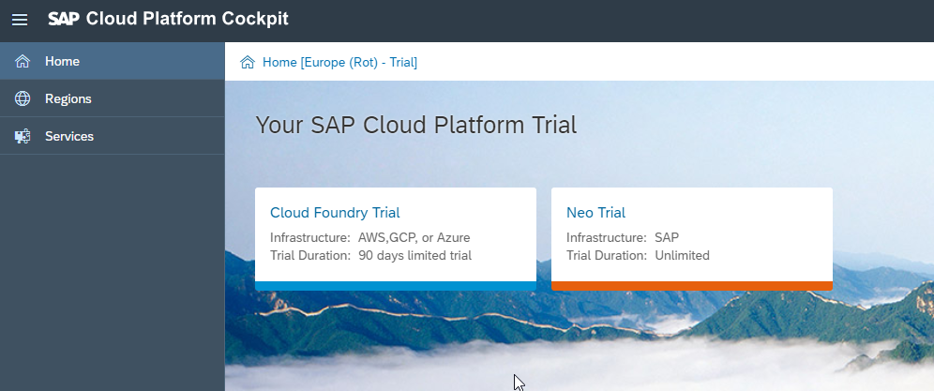

Need additional detail